Practical:01
AIM: Dealing With Data Using Stats Numpy and Pandas Library.
Code:
# Setting up the environment
import numpy as np
import pandas as pd
from statistics import mean, median, stdev
import matplotlib.pyplot as plt

# 1. NumPy Operations
# Creating arrays
array_1d = np.array([10, 20, 30, 40, 50])
array_2d = np.array([[1, 2], [3, 4], [5, 6]])

# Performing mathematical operations
array_sum = array_1d + 5
array_mean = np.mean(array_1d)
array_std = np.std(array_1d)

# Generating a range and random numbers
range_array = np.arange(1, 10, 2)
random_array = np.random.rand(3, 3)

# Reshaping an array
reshaped = random_array.reshape(1, 9)

# 2. Pandas Operations
# Creating a DataFrame
data = {
"Name": ["Alice", "Bob", "Charlie", "David", "Eva"],
"Age": [25, 30, 35, 40, 45],
"Score": [85, 90, 78, 88, 76]
}
df = pd.DataFrame(data)

# Inspecting data
print(“Hansha Rathod : 2203031050220”)
print(df.head())
print(df.describe())

# Filtering and sorting
filtered_df = df[df["Score"] > 80]
sorted_df = df.sort_values(by="Age", ascending=False)

# Data manipulation
df["Bonus"] = df["Score"] * 0.1
df.loc[df["Name"] == "Alice", "Score"] = 95
df.drop(columns=["Bonus"], inplace=True)

# Handling missing values
df.loc[2, "Score"] = None
df["Score"] = df["Score"].fillna(df["Score"].mean())

# 3. Statistics Library Operations
scores = df["Score"].tolist()
print("Mean:", mean(scores))
print("Median:", median(scores))
print("Standard Deviation:", stdev(scores))

# 4. Visualization
# Histogram
df["Score"].hist()
plt.title("Score Distribution")
plt.xlabel("Score")
plt.ylabel("Frequency")
plt.show()

# Bar chart
df.plot(x="Name", y="Score", kind="bar", title="Scores by Name")
plt.show()
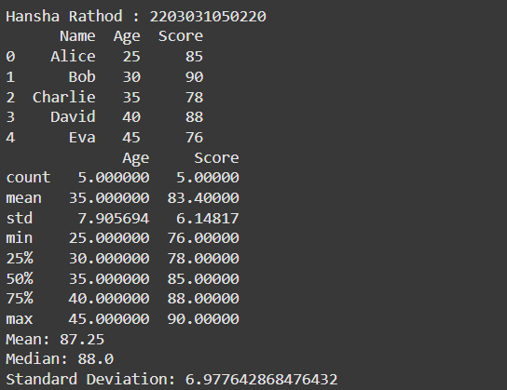

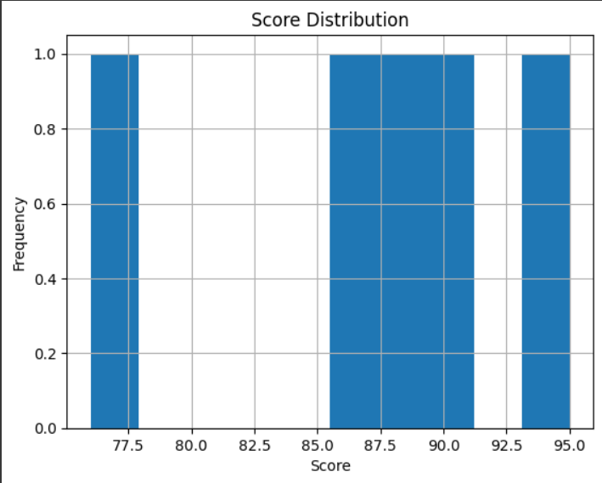
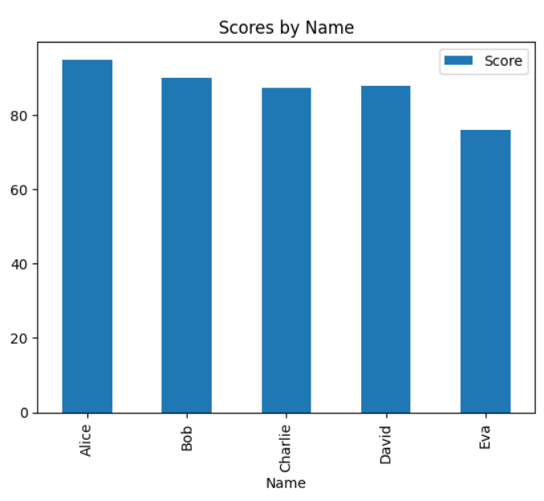

Practical:02
AIM: Data Analysis & Visualization on Diwali Sales Dataset.
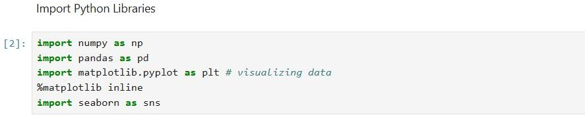
- Importing Python Libraries
- Data Loading

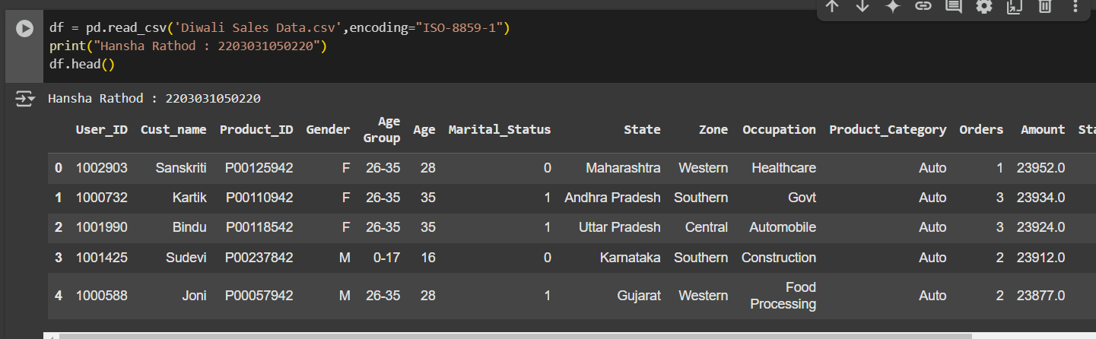
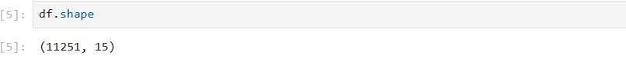

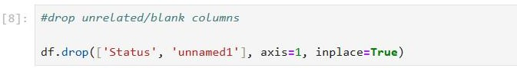
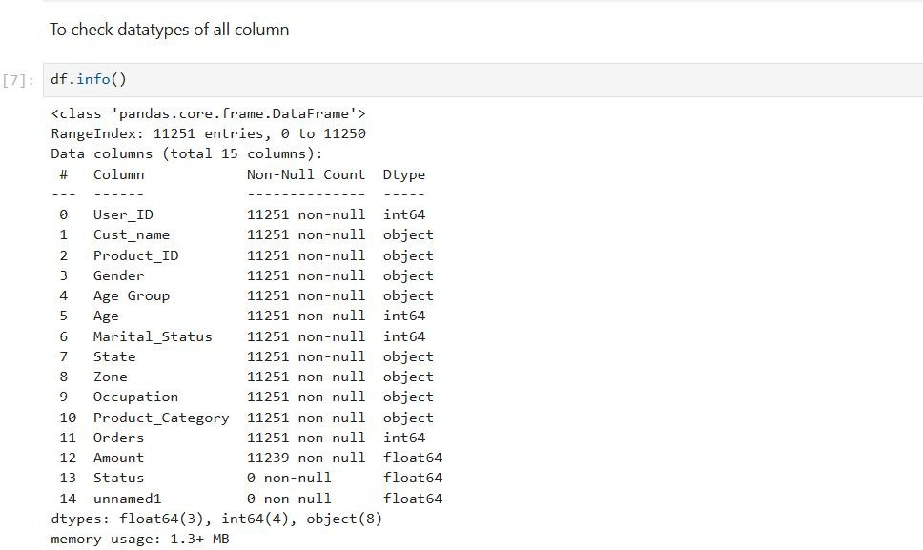
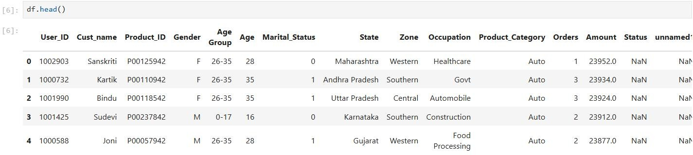
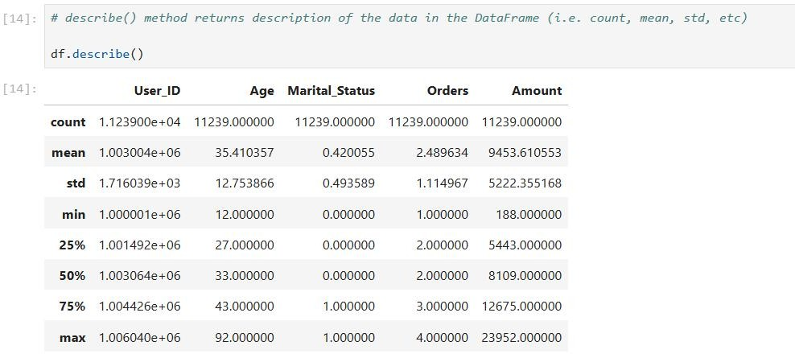
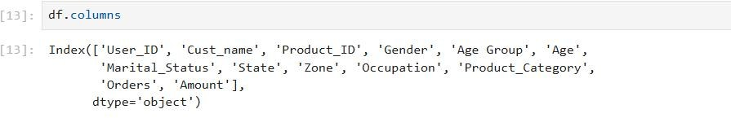
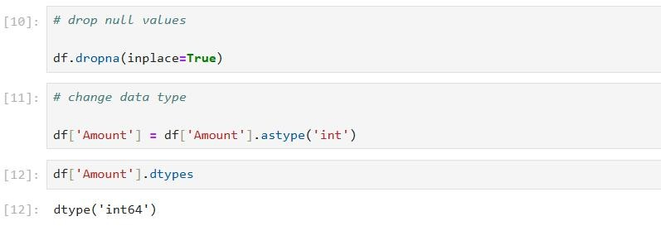
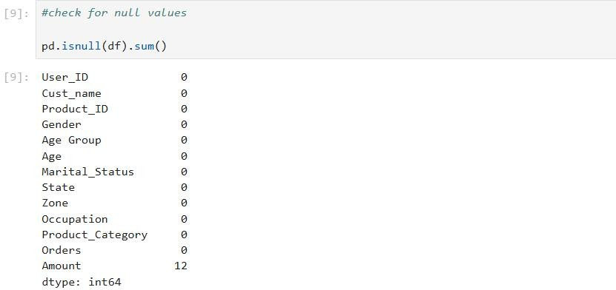

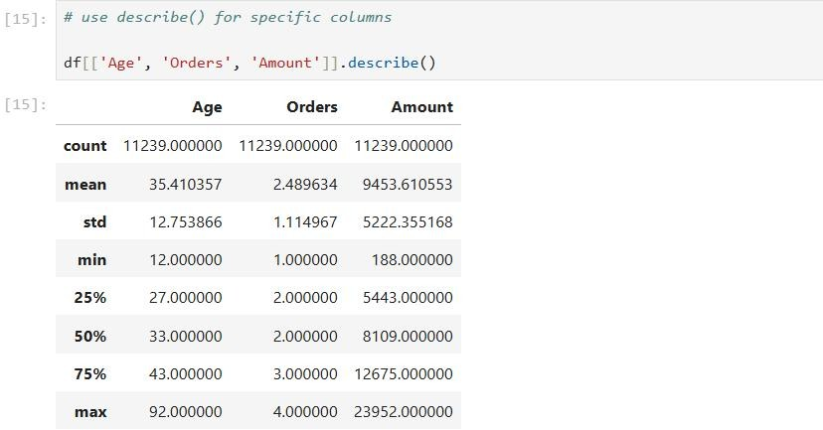
- Exploring Data Analysis
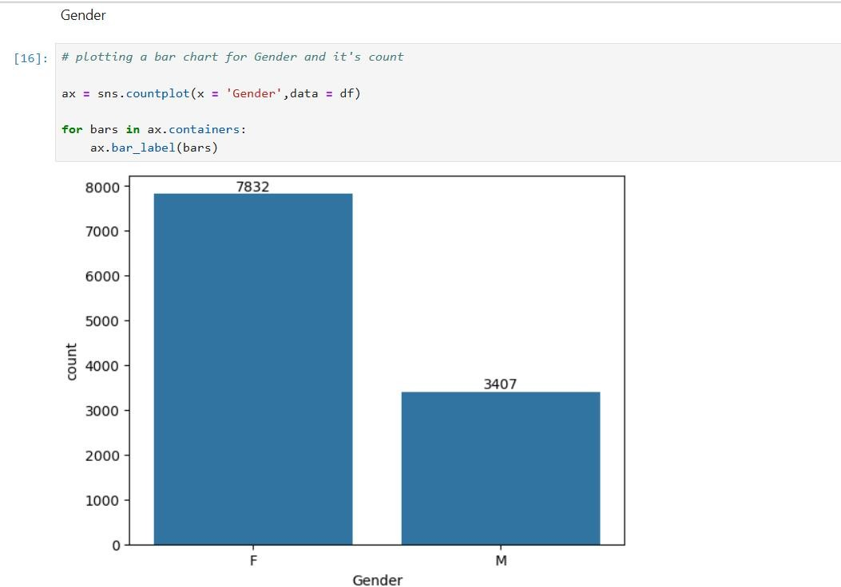

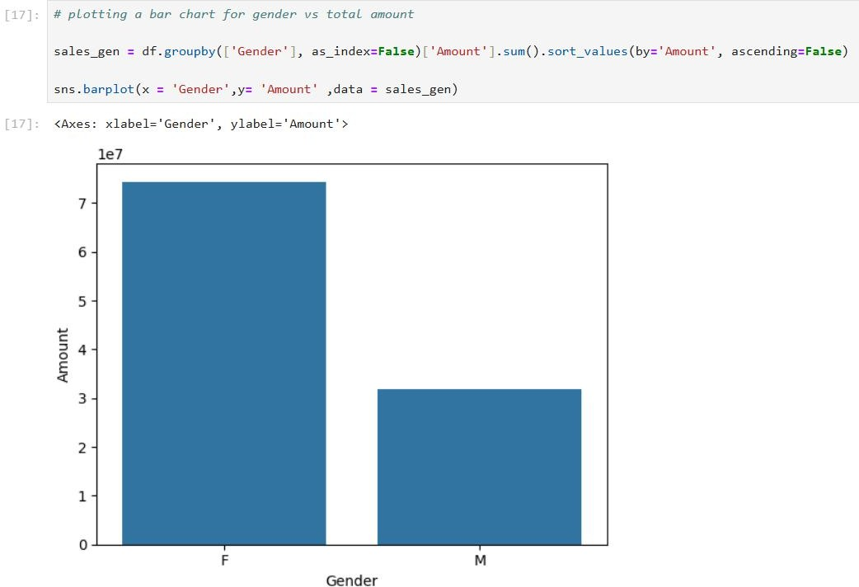
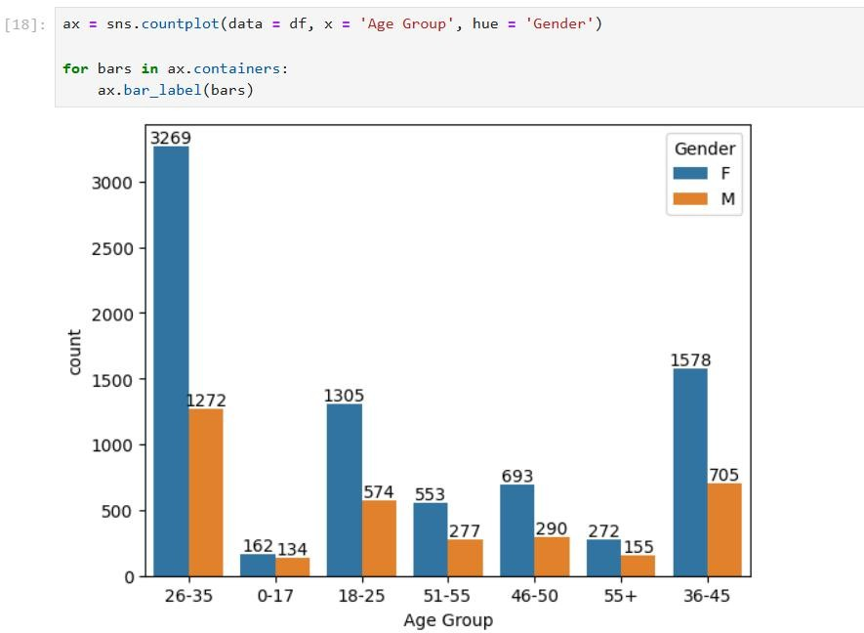
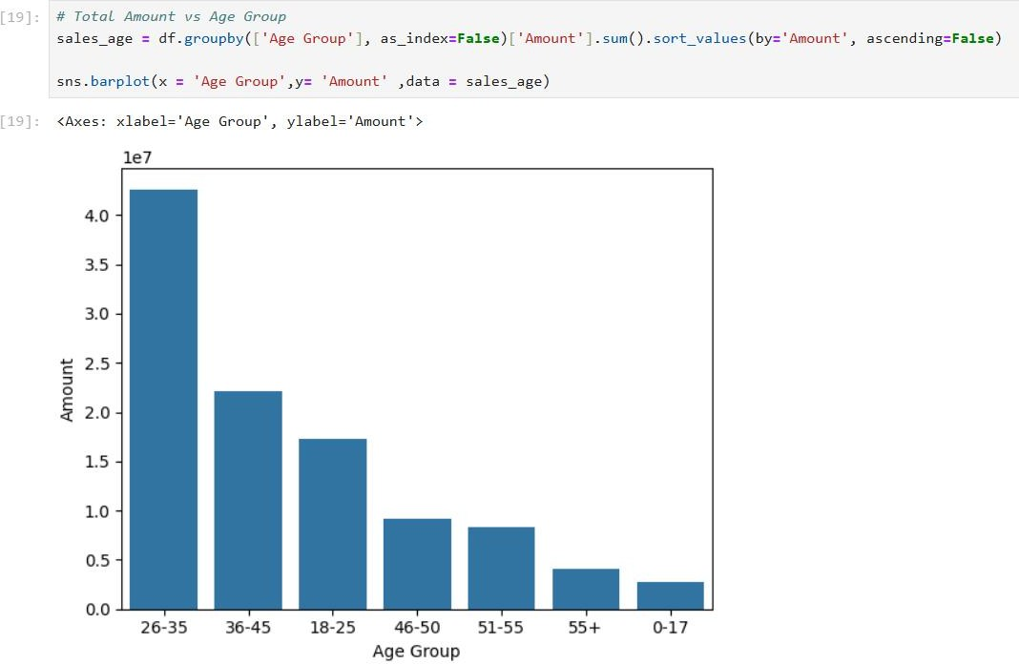
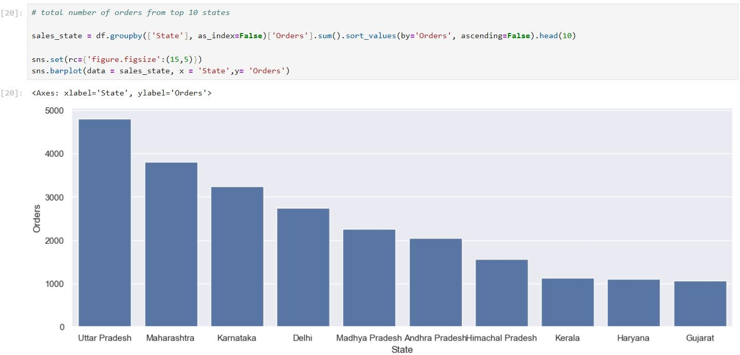

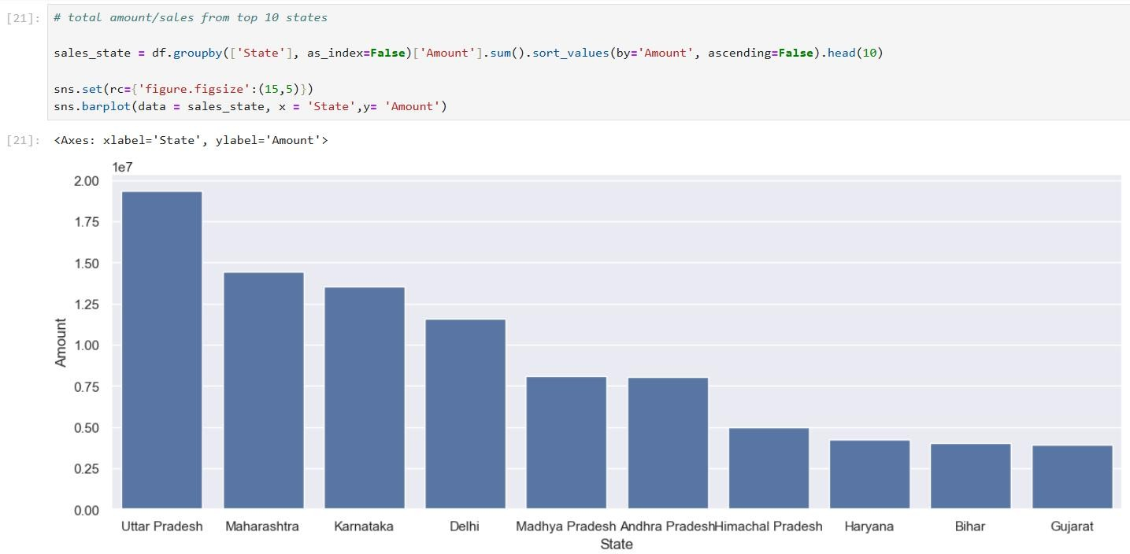
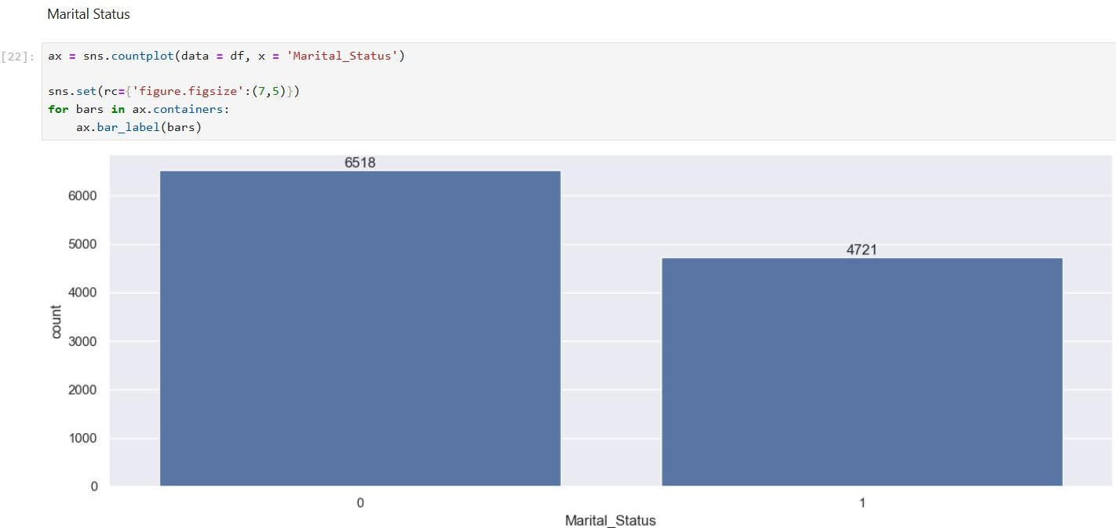

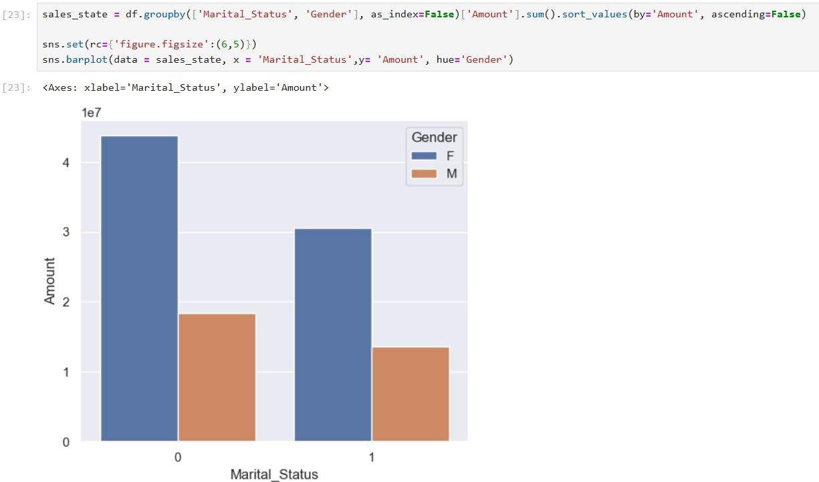
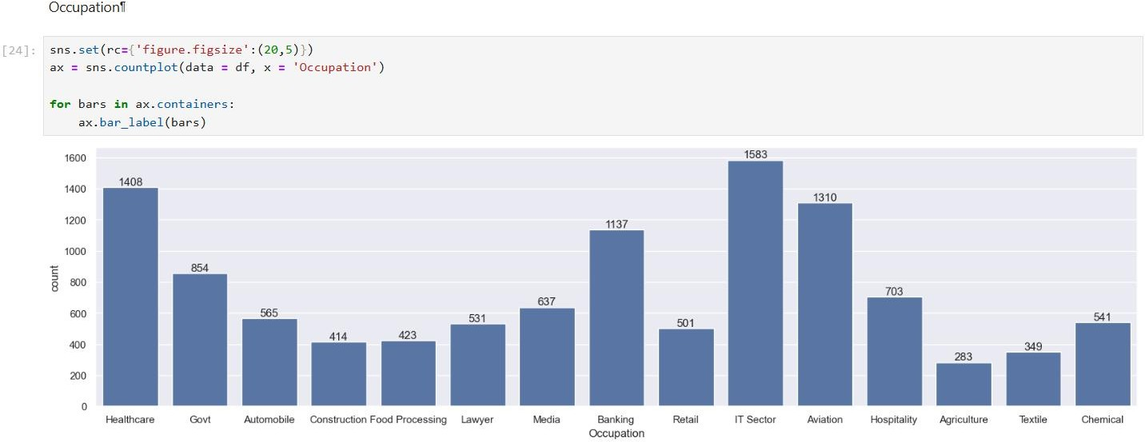

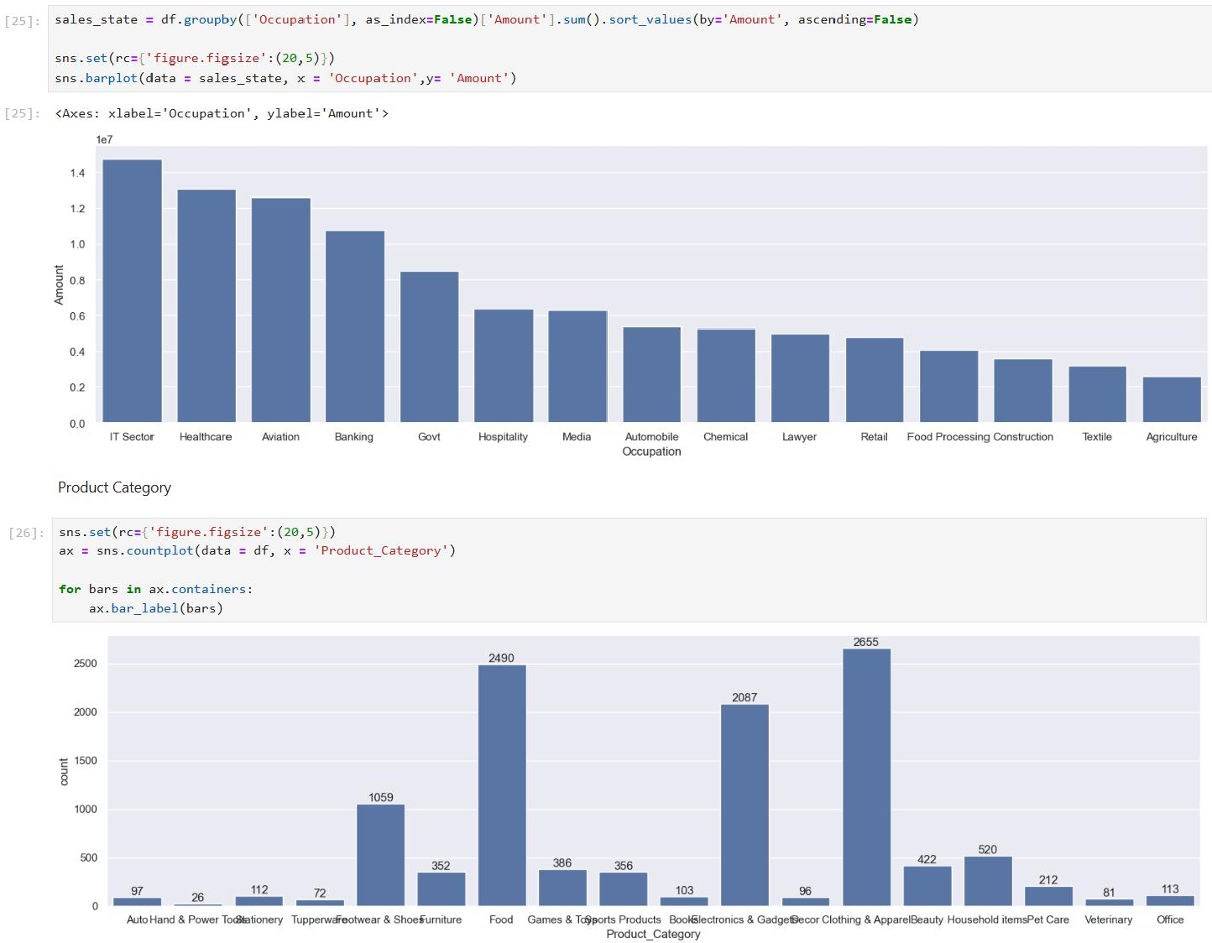
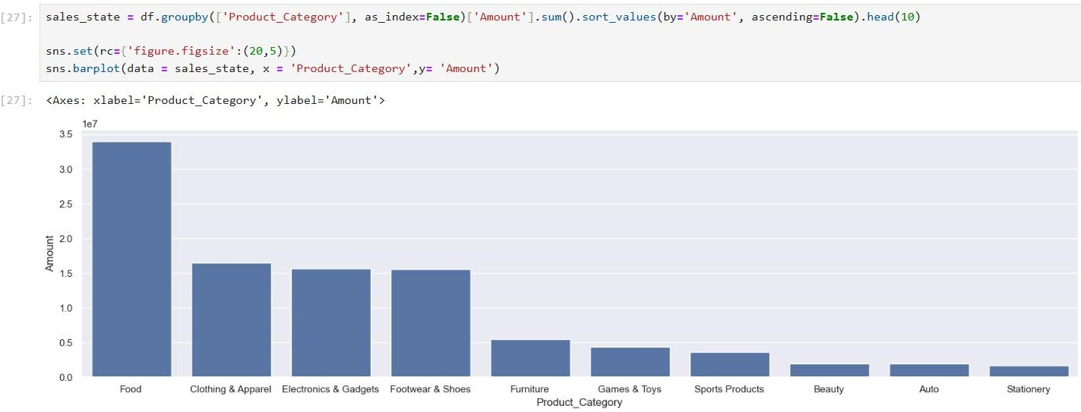

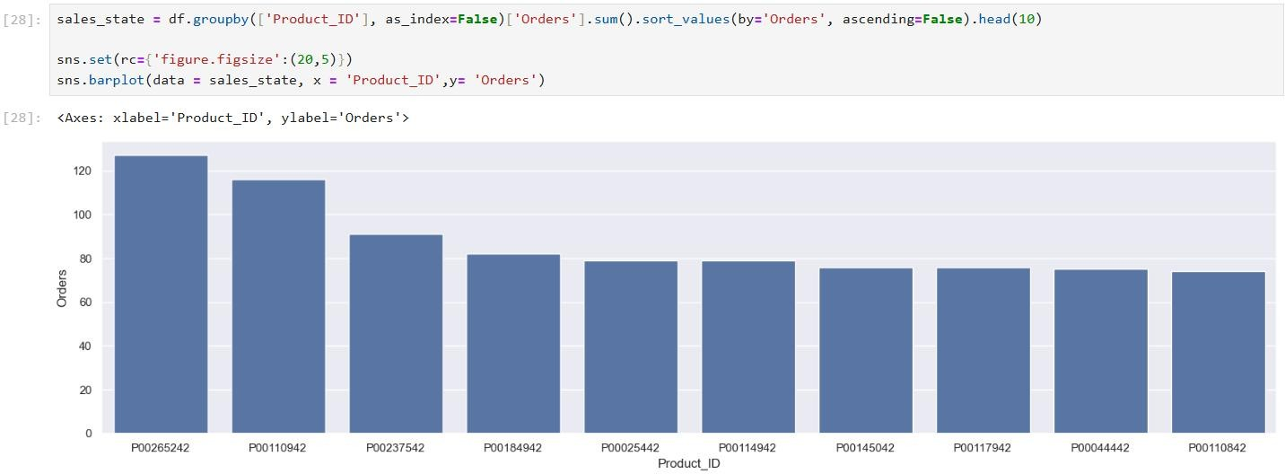
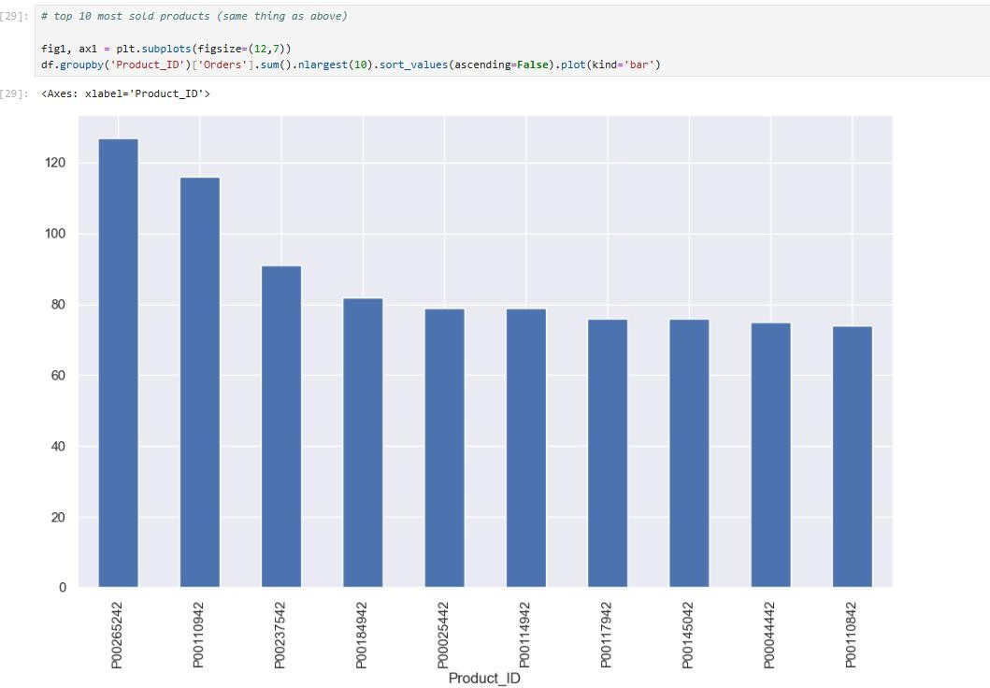

Practical:03
AIM: Write a program to demonstrate the working of the decision tree-based ID3 algorithm.
- Linear Regression

Code:
import pandas as pd
import numpy as np
import matplotlib.pyplot as plt
import seaborn as sns

from sklearn.model_selection import train_test_split
from sklearn.linear_model import LinearRegression
from sklearn.metrics import mean_squared_error, r2_score

# Load dataset
data = pd.read_csv("Salary_dataset.csv")
print("Columns in the dataset:", data.columns)

# Independent and dependent variables
X = data['YearsExperience'].values # Independent variable
Y = data['Salary'].values # Dependent Variable

# Calculate means of X and Y
X_mean = np.mean(X)
Y_mean = np.mean(Y)

# Calculate slope (b1) and intercept (b0)
numerator = np.sum((X - X_mean) * (Y - Y_mean))
denominator = np.sum((X - X_mean) ** 2)

b1 = numerator / denominator
b0 = Y_mean - b1 * X_mean

# Prediction
Y_pred = b1 * X + b0

# Visualization
plt.scatter(X, Y, color="blue", label="Data Points")
plt.plot(X, Y_pred, color="red", label="Regression Line")
plt.xlabel("Years of Experience")
plt.ylabel("Salary")
plt.title("Simple Linear Regression")
plt.legend()
plt.show()

# Evaluation: Mean Squared Error (MSE)
mse = np.mean((Y - Y_pred) ** 2)

# Print results
print(f"Slope (b1): {b1}")
print(f"Intercept (b0): {b0}")
print(f"Mean Squared Error: {mse}")

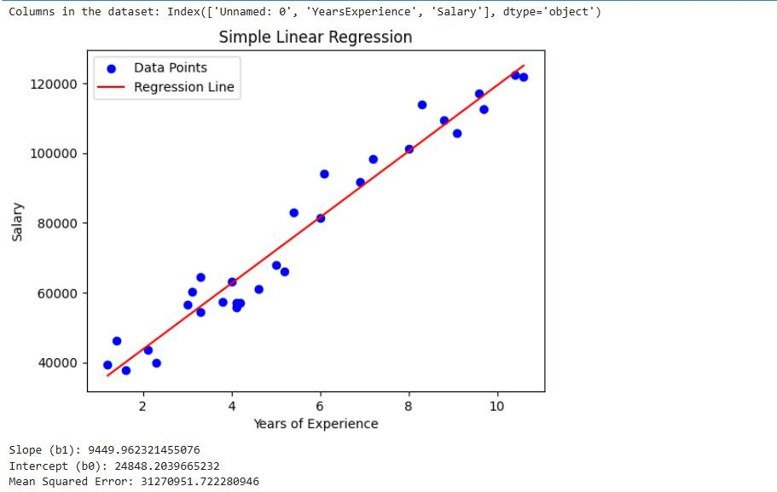
Output:

- Linear Regression

Code:
import pandas as pd
import numpy as np
import matplotlib.pyplot as plt
import seaborn as sns
from sklearn.datasets import make_classification
from sklearn.model_selection import train_test_split
from sklearn.linear_model import LogisticRegression
from sklearn.metrics import accuracy_score, confusion_matrix, classification_report

# Generate synthetic binary classification data
X, y = make_classification(n_samples=100, n_features=2, n_classes=2, n_informative=2, n_redundant=0, random_state=0)

# Split the data into training and testing sets
X_train, X_test, y_train, y_test = train_test_split(X, y, test_size=0.2, random_state=42)

# Create and fit the model
model = LogisticRegression()
model.fit(X_train, y_train)

# Make predictions
y_pred = model.predict(X_test)

# Evaluate the model
accuracy = accuracy_score(y_test, y_pred)
conf_matrix = confusion_matrix(y_test, y_pred)
class_report = classification_report(y_test, y_pred)

# Plot the results
plt.scatter(X[:, 0], X[:, 1], c=y, cmap='viridis', edgecolor='k', s=50)
plt.title("Logistic Regression Classification")
plt.xlabel("Feature 1")
plt.ylabel("Feature 2")
plt.show()

# Print evaluation metrics
print("Accuracy:", accuracy)
print("Confusion Matrix:\n", conf_matrix)
print("Classification Report:\n", class_report)
Output:
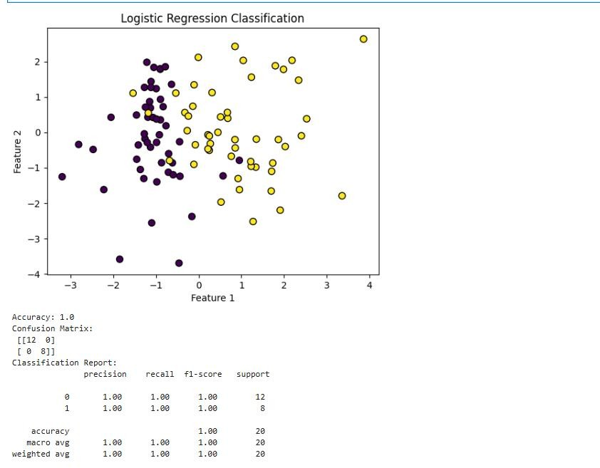
Practical:04
AIM: Implement the naive Bayesian classifier for a sample training data set stored as a .CSV file. Compute the accuracy of the classifier, considering a few test data sets.

What is Naïve Baye’s Classifier?
- The Naive Bayes classifier is a family of probabilistic algorithms based on Bayes' Theorem, which is used for classification tasks.
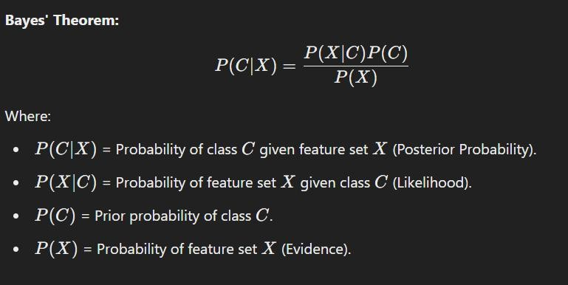
- The algorithm assumes that the presence of a particular feature in a class is independent of the presence of any other feature, which is why it is called “naive.”

Code:
import pandas as pd
import numpy as np
from sklearn.model_selection import train_test_split
from sklearn.naive_bayes import GaussianNB
from sklearn.metrics import accuracy_score, classification_report, confusion_matrix

# Load dataset
data = pd.read_csv("train_data.csv")
X = data.iloc[:, :-1]
y = data.iloc[:, -1]
X = pd.get_dummies(X)

# Split data into training and testing sets
X_train, X_test, y_train, y_test = train_test_split(X, y, test_size=0.6, random_state=42)

# Apply Naive Bayes
classifier = GaussianNB()
classifier.fit(X_train, y_train)

# Make predictions
y_pred = classifier.predict(X_test)

# Evaluate the model
accuracy = accuracy_score(y_test, y_pred)
confusion = confusion_matrix(y_test, y_pred)
report = classification_report(y_test, y_pred)

# Print evaluation metrics
print("\nAccuracy of the Naive Bayes Classifier: {:.2f}%".format(accuracy * 100))
print("\nConfusion Matrix:\n", confusion)
print("\nClassification Report:\n", report)

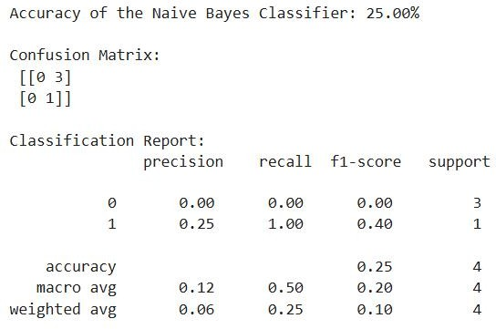
Output:

Practical:05
AIM: Assuming a set of documents that need to be classified, use the naive Bayesian Classifier model to perform this task.
The Naive Bayesian Classifier is commonly used for text classification tasks, such as spam detection or document categorization. Here’s an implementation in Python using the Multinomial Naive Bayes model from scikit-learn to classify documents.

Steps:

- Preprocess the text data (tokenization, removing stop words, etc.).
- Convert text into numerical features using techniques like TF-IDF or Count Vectorization.
- Train a Naïve Bayesian Classifier.
- Predict and evaluate the model.

Code:
from sklearn.feature_extraction.text import TfidfVectorizer
from sklearn.model_selection import train_test_split
from sklearn.naive_bayes import MultinomialNB
from sklearn.metrics import classification_report, accuracy_score

# Sample text data
documents = [
"I love programming in Python",
"Python is a great programming language",
"JavaScript is versatile and used widely",
"I enjoy creating web applications with JavaScript",
"Machine learning is fascinating",
"I love studying artificial intelligence",
"The AI revolution is here",
"Web development with JavaScript is popular"
]
labels = ["Python", "Python", "JavaScript", "JavaScript", "AI", "AI", "AI", "JavaScript"]

# Split the dataset
X_train, X_test, y_train, y_test = train_test_split(documents, labels, test_size=0.25, random_state=42)

# Vectorize the text data
vectorizer = TfidfVectorizer()
X_train_tfidf = vectorizer.fit_transform(X_train)
X_test_tfidf = vectorizer.transform(X_test)

# Train Naive Bayes classifier
model = MultinomialNB()
model.fit(X_train_tfidf, y_train)

# Make predictions
y_pred = model.predict(X_test_tfidf)

# Evaluate the model
accuracy = accuracy_score(y_test, y_pred)
print(f"Accuracy: {accuracy:.2f}")
print("\nClassification Report:")
print(classification_report(y_test, y_pred))

# Predict new documents
new_documents = ["Python is used for data science", "Web developers use JavaScript a lot"]
new_tfidf = vectorizer.transform(new_documents)
predictions = model.predict(new_tfidf)

print("\nPredictions for new documents:")
for doc, label in zip(new_documents, predictions):
print(f"Document: {doc} -> Predicted Label: {label}")
Output:
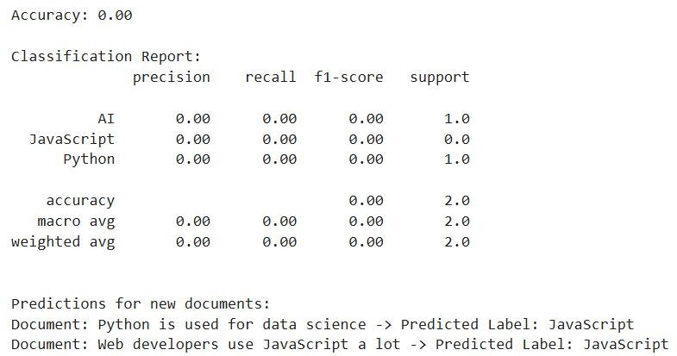

Practical:06
AIM: Write a program to demonstrate the working of the decision tree-based ID3 algorithm.
What is ID3 algorithm?
The ID3 (Iterative Dichotomiser 3) algorithm is a widely used method for creating decision trees in machine learning. It was developed by Ross Quinlan in 1986 and is based on the concept of information gain from information theory.
Key Features of ID3:
- Purpose:
  - To construct a decision tree for classification problems.
  - The resulting tree can be used to predict the class of an instance by navigating from the root to a leaf node.
- Input:
  - A dataset with features (attributes) and a target attribute (class labels).
  - All attributes must be categorical (or discretized).
- Output:
  - A decision tree where each node represents a feature, branches represent feature values, and leaf nodes represent class labels.
How ID3 Works:
- Entropy:
  - It uses entropy to measure the level of impurity or randomness in the dataset. Lower entropy means the data is more homogeneous.
Formula:
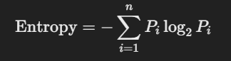
- Information Gain:
- It calculates the information gain for each attribute, which is the reduction in entropy after splitting the data on that attribute.
- The attribute with the highest information gain is selected as the root node or the next decision node.
Formula:
3. Recursive Partitioning:
- The dataset is split into subsets based on the best attribute.
- The process is repeated recursively for each subset until:
  - All data in a subset belong to the same class, or
  - No more attributes are available, or
  - The dataset cannot be split further.
4. Stopping Criteria:
- If all examples in a subset have the same class, the node becomes a leaf.
- If no attributes remain, the node becomes a leaf with the most common class in the subset.
Example Workflow:
- Input Dataset
Let's consider a simple dataset for classifying whether a person will play tennis based on the weather conditions.
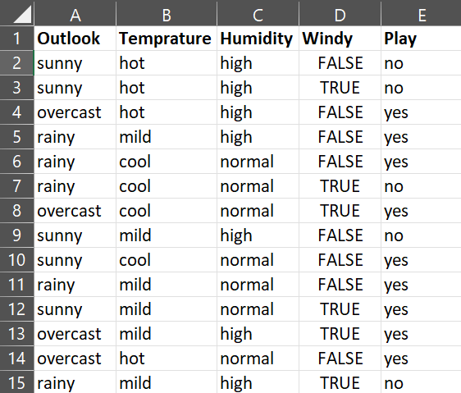
Steps:
- Compute the entropy of the target attribute (PlayTennis).
- Compute information gain for each feature (Outlook, Temperature, Humidity, Wind).
- Choose the feature with the highest information gain as the root node (e.g., Outlook).
- Split the data based on Outlook values (Sunny, Overcast, Rain).
- Repeat recursively for each subset.
Code:
import math
import pandas as pd
import numpy as np

# Helper function: Calculate entropy
def calculate_entropy(data):
elements, counts = np.unique(data, return_counts=True)
return -sum(
(count / len(data)) * math.log2(count / len(data))
for count in counts if count > 0
)

# Helper function: Calculate information gain
def calculate_information_gain(data, feature, target_attribute):
total_entropy = calculate_entropy(data[target_attribute])
values, counts = np.unique(data[feature], return_counts=True)
weighted_entropy = sum(
(counts[i] / sum(counts)) * calculate_entropy(
data[data[feature] == values[i]][target_attribute]
)
for i in range(len(values))
)
return total_entropy - weighted_entropy

# Recursive function to build the decision tree
def build_tree(data, features, target_attribute):
labels = data[target_attribute]

# Base cases
if len(np.unique(labels)) == 1: # Pure node
return labels.iloc[0]
if not features: # No features left
return labels.value_counts().idxmax()

# Find the best feature to split on
info_gains = [calculate_information_gain(data, feature, target_attribute) for feature in features]
best_feature_index = np.argmax(info_gains)
best_feature = features[best_feature_index]

# Initialize tree structure
tree = {best_feature: {}}
remaining_features = [f for f in features if f != best_feature]

# Recursively build subtrees for each value of the best feature
for value in np.unique(data[best_feature]):
subset = data[data[best_feature] == value]
subtree = build_tree(subset, remaining_features, target_attribute)
tree[best_feature][value] = subtree

return tree

# Function to display the decision tree
def display_tree(tree, depth=0):
if isinstance(tree, dict):
for key, value in tree.items():
print(f"{'| ' * depth}{key}")
display_tree(value, depth + 1)
else:
print(f"{'| ' * depth}--> {tree}")

# Main function to demonstrate ID3
def main():
print("Name: Hansha Rathod")
print("En no: 2203031050220")

# Example dataset
data = {
"Outlook": ["Sunny", "Sunny", "Overcast", "Rain", "Rain", "Rain", "Overcast", "Sunny", "Sunny", "Rain", "Sunny", "Overcast", "Overcast", "Rain"],
"Temperature": ["Hot", "Hot", "Hot", "Mild", "Cool", "Cool", "Cool", "Mild", "Cool", "Mild", "Mild", "Mild", "Hot", "Mild"],
"Humidity": ["High", "High", "High", "High", "Normal", "Normal", "Normal", "High", "Normal", "Normal", "Normal", "High", "Normal", "High"],
"Wind": ["FALSE", "TRUE", "FALSE", "FALSE", "FALSE", "TRUE", "TRUE", "FALSE", "FALSE", "FALSE", "TRUE", "TRUE", "FALSE", "TRUE"],
"PlayTennis": ["No", "No", "Yes", "Yes", "Yes", "No", "Yes", "No", "Yes", "Yes", "Yes", "Yes", "Yes", "No"],
}
df = pd.DataFrame(data)

# Define features and target attribute
target_attribute = "PlayTennis"
features = list(df.columns[:-1])

# Build and print the decision tree
decision_tree = build_tree(df, features, target_attribute)
print("\nDecision Tree:")
display_tree(decision_tree)

# Run the main function
if __name__ == "__main__":
main()
Output:
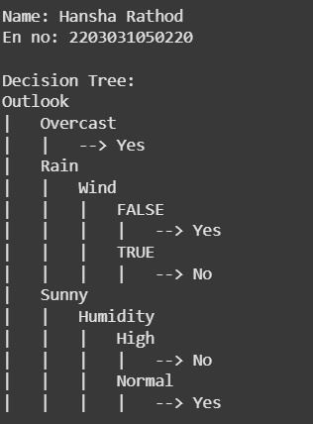
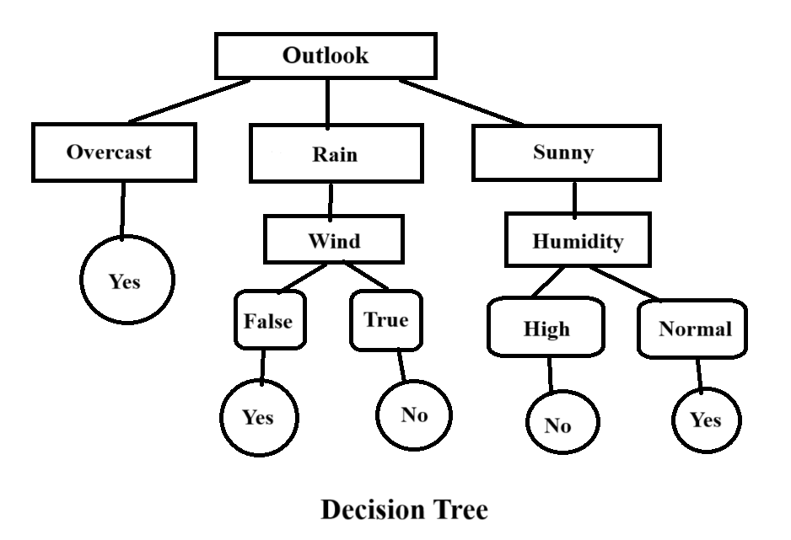
Advantages:
- Simple and intuitive.
- Works well with small datasets and categorical data.
- Produces human-readable rules.
Disadvantages:
- Sensitive to noisy data.
- Tends to overfit if the tree grows too deep.
- Cannot handle continuous data directly without preprocessing.
Applications:
- Spam detection.
- Customer classification.
- Medical diagnosis.
- Game AI (decision-making).

